Spiral 2 Completion Report
Role: Table Generator Developer (Member 2)
Project: UML-Based Generic CRUD Application Generator

1. Objective of Spiral 2 (Member 2 Role)
The primary objective for Member 2 in Spiral 2 was to bridge the gap between the parsed UML JSON data and the MySQL database. Specifically, the task was to write the logic that dynamically generates a valid schema.sql file containing CREATE TABLE statements for every extracted class.
Scope Limitations: As per the Spiral 2 requirements, foreign keys and associations (1:1, 1:*) were intentionally ignored and left for Spiral 3.

2. Inputs Received
- Input: A validated Python dictionary containing extracted UML classes and their attributes (passed from Spiral 1 modules).
- Dependency: The type_mapper.py module created by Member 1, which handles the translation of UML data types to MySQL data types.

3. Work Implemented
Member 2 created the core schema generation logic in schema_generator/schema_generator.py. The module performs the following operations:
- Table Initialization: Iterates through all classes in the model and initializes a CREATE TABLE SQL block.
- Primary Key Injection: Automatically prepends an id INT AUTO_INCREMENT PRIMARY KEY column to every table to ensure database indexing works properly. It also ignores any manually defined "id" attributes from the UML to prevent duplicate primary keys.
- Type Mapping Integration: Iterates over all class attributes, passing the raw UML type to map_type() (from Member 1's logic) to fetch the appropriate SQL data type.
- Syntax Formatting: Concatenates columns with correct comma placement, specifically ensuring that no trailing commas are left at the end of the SQL statement (which would cause a syntax error in MySQL).
- File Generation: Writes the fully formatted string to a deterministic schema.sql file.
Additionally, this module was successfully integrated into the main generate.py pipeline so that it executes automatically after the validation phase.

4. Test Cases & Validation
The generation logic was tested against multiple models:
- Test Case 1 (Local Dummy Data): Tested isolated logic against a hardcoded dictionary containing known types, unknown types, and duplicate ID attributes. Handled perfectly.
- Test Case 2 (model_simple.xmi): Integrated pipeline test. Successfully extracted the Student class and generated a table with id and name VARCHAR(255).
- Test Case 3 (model_complex.xmi): Tested against a heavy structure. Successfully generated discrete tables for Person, Student, Professor, Course, Department, and Enrollment with flawless SQL syntax.
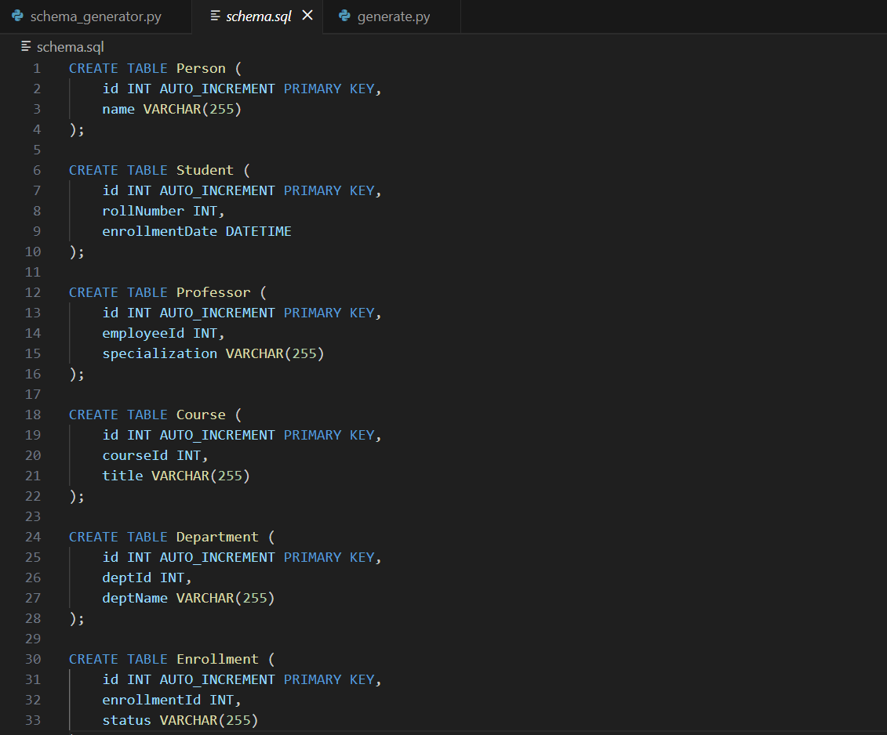
The above screenshot shows the schema.sql generated using the complex model
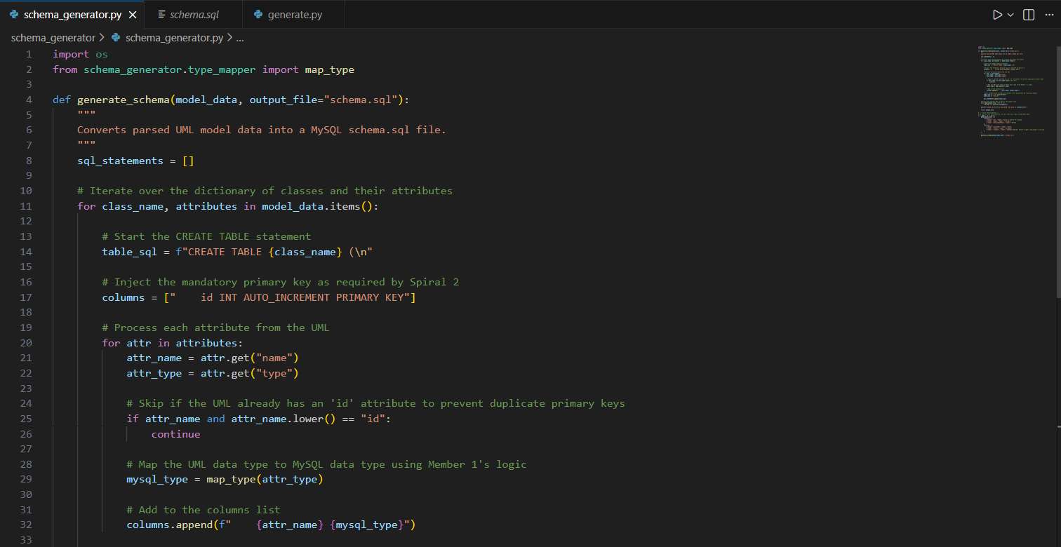
The above screenshot shows a small part of the code of schema_generator.py

5. Conclusion
The responsibilities of Member 2 for Spiral 2 are complete.
- schema_generator.py logic is fully implemented.
- No SQL syntax errors or trailing commas exist.
- Integration with Member 1's type mapping is complete.
- Integration into the main generate.py pipeline is complete.
The database tables are now reliably generating. The project is ready for Member 3 to test the schema directly in MySQL, and then the team can proceed to Spiral 3 to handle Foreign Keys.

